Resource Type: Email Outreach Template
Audience: New, prospective flood insurance clients, including individuals from other lead generation sources (e.g., community listserv, local partnership with realtors/lenders, or other channels you may use).
Directions: Copy and paste the template below into your preferred email platform. HTML email formatting is preferred.

Subject: Urban flooding in [insert area] – add flood insurance coverage from [insert company]
Subject: [insert area]’s flood anniversary is coming up – add flood insurance coverage from [insert company]
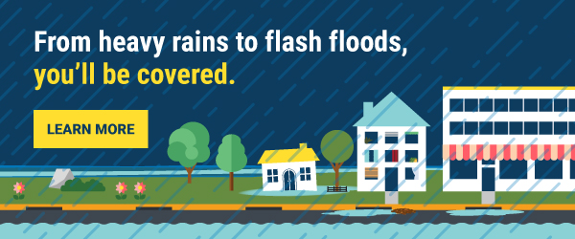
Dear [insert name of city/community] [resident / business owner],
Flooding can happen at any time, and as your local [insert company name] agent, I want to make sure [you are / your family is / your business is] prepared for hidden flood risks in your area.
In towns and cities like [insert area], there’s more development and fewer places for water to go. Heavy rain can become a flash flood in minutes, causing serious damage to your [home and possessions / business].
FEMA and the National Flood Insurance Program (NFIP) are encouraging all [insert area] residents and business owners to purchase flood insurance to protect their homes, families, and businesses.

Here are four things to know about flooding:
- For everyone: Flooding can happen anywhere, at any time. Limited drainage systems, backyard streams, neighborhood construction, and even summer storms can all cause devastating flooding.
- For homeowners: Flooding can happen even if you live far from water. In fact, 40% of NFIP claims came from outside high-risk flood areas between 2015 and 2019.
- For renters: A standard renters insurance policy typically doesn’t cover flood damage. Your landlord may have flood insurance to cover the building you live in, but it's likely that their insurance will not cover your personal belongings should a flood occur.
- For business owners: Almost 40% of small businesses never reopen their doors following a flooding disaster.
Reach out to me with any questions your have or to learn more about the right level of coverage for your [home / business].
[insert email signature with contact information]

