Resource Type: Email Outreach Template
Audience: Existing clients who may have other lines of insurance with you, but not flood insurance.
Directions: Copy and paste the template below into your preferred email platform. HTML email formatting is preferred.

Subject: Do you know your community’s hidden flood risks? Get flood insurance from [insert company] today.
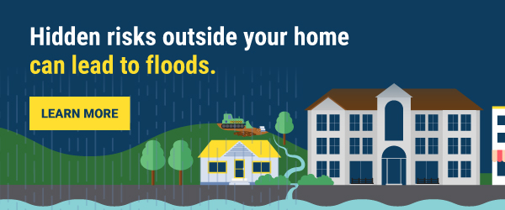
Hi [insert customer name],

Flooding can happen at any time, and I wanted to check-in with [you / your family] to make sure you know your area’s hidden flood risks.

In towns and cities like [insert area], there’s more development and fewer places for water to go. Heavy rain can become a flash flood in minutes, causing serious damage to your [home and possessions / business].

FEMA and the National Flood Insurance Program (NFIP) are encouraging all [insert area] residents to purchase flood insurance to protect their homes, families, and businesses. Keep in mind, policies typically take up to 30 days to go into effect so don’t wait, get flood insurance today!

Your current [insert type of policy they currently have with you, i.e. homeowners, renters, auto, or other commercial insurance policy] policy, although important for other protections, does not cover flood damage. Buying flood insurance is one of most important steps you can take to protect the life you’ve built.



Reach out to me with any questions you have or to learn more about the right level of coverage for your [home / business].

[insert email signature with contact information]

P.S. Here are four things to remember about flooding:
- For everyone: Flooding can happen anywhere, at any time. Limited drainage systems, backyard streams, neighborhood construction, and even summer storms can all cause devastating flooding.
- For homeowners: Flooding can happen even if you live far from water. In fact, 40% of NFIP claims came from outside high-risk flood areas between 2015 and 2019.
- For renters: A standard renters insurance policy typically doesn’t cover flood damage. Your landlord may have flood insurance to cover the building you live in, but it's likely that their insurance will not cover your personal belongings should a flood occur.
- For business owners: Almost 40% of small businesses never reopen their doors following a flooding disaster.

